**Holy Family Community School**

**Rathcoole, Co. Dublin**



**Strategic Plan**

**2017 to 2021**

Table of Contents

1. Management Introductions 2

2. History & Context 3

3. School Demographics 5

4. Recent School Milestones and Highlights 7

5. Methodology of the Planning Process 10

6. Vision Statement 12

7. Organisation Structure 13

8. What We Heard From Our Students 14

9. What We Heard From Our Staff 15

10. What We Heard from Our Parents 16

11. Strategic Framework 17

12. Pillar 1. Teaching & Learning 18

13. Pillar 2. Infrastructure / Facilities 22

14. Pillar 3. Health, Wellbeing Lifestyle Students & Staff 26

15. Pillar 4. Communication 30

16. Pillar 5. Leadership & Management 34

17. Implementing and Reviewing the Plan 39

18. Acknowledgements 39

# Management Introductions

The Board of Management is pleased to present this Strategic Plan for Holy Family Community School. The launch of this Strategic Plan marks another important stage in the continuous development of Holy Family Community School. The Plan provides a blueprint for the future of the school which builds on its traditions and values. I look forward to seeing this plan translated into actions which will further enhance the opportunities and educational provision for students in Holy Family Community School. On behalf of the Board of Management, I thank all who collaborated in the preparation of this Strategic Plan which will benefit the whole school community over the coming years.

**Mr. Dermot Lahey**

**Chairperson, Board of Management**

Holy Family Community School has undergone many changes since it opened in 1981. We welcome this Strategic Plan which was developed in collaboration with all our partners in education. It expresses our cohesive vision, charts a direction for the school and sets aspirational and achievable goals for future growth and improvement. Holy Family Community School will use this plan to confidently face the exciting challenges and opportunities ahead, including providing for increasing student, staff and management populations, building a new school and embracing educational initiatives including the new Junior Cycle Programme and eLearning. Our strategic plan continues our tradition of having the holistic development, academic success and happiness of our students at its heart.

**Ms. Brenda Kelly Mr. Christy Morrin Ms. Ingrid Fallon**

**Principal Deputy Principal Deputy Principal**

# History & Context

Holy Family Community School is a co-educational, multidenominational post-primary school that caters for students living in the catchment area of Rathcoole, Saggart and Newcastle. The school is run by a Board of Management consisting of nominees of the Trustees, teachers and parents. The Trustees appointed to the school are the Spiritan Education Trust (formerly the Holy Ghost Fathers), the Presentation Sisters and Dublin and Dún Laoghaire Educational Training Board (formerly the County Dublin Vocational Education Committee). The Board of Management ensures that the school’s policies and procedures are developed collaboratively with input from staff, Parents’ Council and Students’ Council.

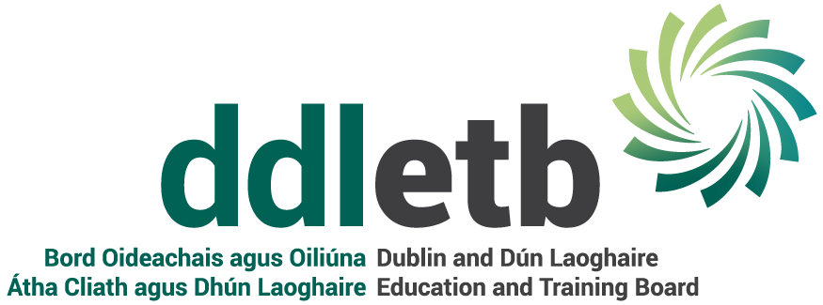

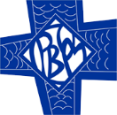

Holy Family Community School was built on a green field site and opened its doors to 73 students in September, 1981 under the leadership of Fr. Noel Redmond, Chairperson of the Board of Management, Mr. Tomás Ó Séaghdha, Principal and Mr. John Walsh, Deputy Principal. By 1985 the original school building, Phase 1, was unable to accommodate the increasing school population. In September, 1986, a new additional building, Phase 2, was opened followed by Phase 3 in 1998, a P.E. Hall in 1999, Phase 4 in 2011 and Phase 5 in 2017. Over the past 36 years, in response to changing school needs, major refurbishment and conversion works were carried out in Phase 1 and Phase 2. In 2004 the Board of Management began its campaign to have a new school built. Planning permission has been granted for this new school.

The school has been progressive in adopting new subjects, programmes and educational initiatives in response to the changing curricular needs of its students and to national educational developments. The school is committed to continually providing and developing its equipment, resources, Special Educational Needs provision and ICT facilities to enhance teaching and learning. This commitment to teaching and learning and to helping all students reach their full potential has been acknowledged in subject inspections and whole school evaluation reports and continues to be a focus of the school’s self-evaluation process.



The pursuit of academic excellence and the development of the whole person is at the heart of the school’s ethos. This is realised through the commitment to curricular, co-curricular and extra-curricular activities, the Pastoral Care System and the Student Support Team. Students are encouraged to participate in extracurricular activities and past students fondly remember school trips and their exploits on the playing field and on the stage. Holy Family Community School promotes activities that help foster students’ commitment to serving others and improve students’ global vision. The school community is very proud of its track record in fundraising for charities, especially Concern.



The characteristic spirit of our school is that of partnership with all the school’s communities - the Board of Management, staff, parents, students, past students, primary schools and the local community. The school’s educational objectives are achieved through these partnerships. The collaboration between the school’s partners creates a vibrant and positive atmosphere and it contributes greatly to the culture of mutual friendliness and respect that permeates the school.

# School Demographics

|  |  |  |  |  |  |  |
| --- | --- | --- | --- | --- | --- | --- |
| **Enrolment** | **2012 /2013** | **2013 / 2014** | **2014 / 2015** | **2015 / 2016** | **2016 / 2017** | **2017 / 2018** |
| Males | 493 | 492 | 491 | 498 | 484 | 517 |
| Females | 336 | 376 | 378 | 382 | 410 | 442 |
| **Total** | **829** | **868** | **869** | **880** | **894** | **959** |

|  |  |  |  |  |  |  |  |
| --- | --- | --- | --- | --- | --- | --- | --- |
| **Enrolment** | **1st Yr** | **2nd Yr** | **3rd Yr** | **TY** | **5th Yr** | **6th Yr** | **LCA** |
| Male | 99 | 95 | 101 | 29 | 95 | 84 | 14 |
| Female | 79 | 85 | 79 | 31 | 76 | 88 | 4 |
| **Total** | 178 | 180 | 180 | 60 | 171 | 172 | 18 |

**2017 / 2018**

# Recent School Milestones and Highlights

* A new school building project is in progress. Planning permission has been granted and we are waiting permission to go to tender.
* Mixed ability classes were introduced in Junior Cycle in September, 2014.
* The school had a Whole School Evaluation – Management, Leadership and Learning (WSE-MLL) in September, 2013 and a Follow-Through inspection in March, 2015.
* The school had a French inspection in 2006, a Transition Year Programme Evaluation in 2007, a Metalwork and Engineering inspection in 2008, a Gaeilge inspection in 2009, a Mathematics inspection in 2010, a Science and Biology inspection and a History inspection in 2011, an Art inspection in 2016 and a German inspection in 2017.
* The Leaving Certificate Vocational Programme was introduced in 2011.
* Holy Family Community School students have been awarded academic / sports scholarships to third level institutions every year



* The school has organised school tours to France in 2011 and 2013, Stratford in 2014, Berlin in 2015 and France in 2016.
* The school was awarded a Special Passport from World Wise Global Schools for its work and involvement in Development Education in 2016/2017.
* The school was awarded European Ambassador School status in 2016/2017.
* The school was recognised for its participation and contribution to centenary events held in the Four Districts in 2016.
* The school was one of only three schools to win a special award in the Creative Yeats National Secondary Schools competition in 2015.
* Lauren Davis and Emily Moore won the North Kildare Soroptimist Ireland Public Speaking Competition in 2014 and 2017 respectively.
* The school won the 1913 Lockout competition organised by Robert Dowds, T.D. and Emer Costello, M.E.P.
* Cian O’Hara reached the top 100 in the All-Ireland Linguistics Olympiad and was one of eight students on Team Ireland in the International Olympiad 2017.
* Fionn Kelly and Jordan Mulligan won the Dublin finals of the Young Technologist of the Year Competition in 2015.
* Bronze Gaisce awards were achieved by 23 students in 2015/2016 and 30 students in 2016/2017.



[](https://www.google.ie/url?sa=i&rct=j&q=&esrc=s&source=images&cd=&ved=0ahUKEwi-3IWNzfnLAhVFKg4KHQfrDsUQjRwIBw&url=https://palatinegirlsxc.wordpress.com/summer-early-bird-running/&bvm=bv.118443451,d.ZWU&psig=AFQjCNFPp1PlhNqbBvlVcqtU4xfH-fE-EA&ust=1460017677376780)



* The school ran three Positive Mental Health Weeks with the themes ‘Lean on me’, ‘It’s the Little Things’, Life is a Rollercoaster’
* The school was awarded the Amber Flag in 2017 for its work promoting positive mental health.
* The school collected €7,202 for Concern in 2016/2017 bringing the total collected since1981 to €702,652.
* The school was awarded a trip to Mali to visit the Concern Centres in 2015.
* The school participated in volunteer programmes to Kenya in 2008 and Nepal 2010.
* The Parents’ Council organised a very successful Race Night and raffle in 2017 raising almost €10,000 for student facilities.
* The ‘Early Bird Enterprise’ (Breakfast Club) was established in 2016 and has partnered with Tesco Ireland’s Food Cloud Programme.



* The school held a very successful Art Exhibition in Celbridge Library showcasing students’ work in 2016/2017.
* The school has had five showcase productions in the Moat Theatre, Naas including two original juke-box musicals written by staff members.
* The school has held a variety of concerts for various events including Positive Mental Health Weeks and the 1916 commemorations.
* The school has been involved in three Emmanual Concerts in the Helix and performed at the launch of the John Paul II awards in the Mansion House.
* The school received an award for participating in the St. Vincent De Paul Annual Carol Service for twenty five years.
* The school has held the ‘Best Overall School’ award in the CCSSCA athletics for the past 13 years.
* The school has held the ‘Best Overall School’ award in the Leinster Community Schools’ Cross Country Championship in all age groups for the past 4 years.
* Jennifer McAdams finished in the top 3 in All-Ireland Athletics 1500m event in 2017.
* Mustafe Nasir broke the record for the 800m in the Tailteann Games finishing in 1:53:98 minutes.
* Joseph Lyons won bronze and silver in the 800m and 400m respectively in the Leinster Schools’ Athletics Competition.



* Louise Masterson was capped for the Irish Ladies’ Soccer Team.
* Claire Walsh was selected for the Irish Senior Ladies’ Soccer Team.
* Rachel McGrath was selected for the Leinster Schools’ Soccer Team in 2017.
* The school won the first year boys’ Dublin Colleges soccer final in 2016.
* The school won the Dublin South Colleges Soccer Final in 2015/2016. Three players from this team are now on semi-professional contracts.
* The school won the under 16 Dublin Colleges Gaelic football championship and were runners up in the Leinster Final in 2017.
* Ciara Trant won an All-Ireland Gaelic football medal in 2017 with the Dublin Senior Ladies Football Team.
* The school won the under 14 and under 16 Dublin Colleges Hurling final in 2015/2016.
* The school reached the All-Ireland basketball finals in 2010 and the All-Ireland semi-finals in 2014.
* The school’s first year boys’ basketball team won the Dublin Colleges Shield in 2013.
* Eoin Murphy and Robert White played for the under 14 and under 16 Ireland basketball teams.
* Emma Perry is an FIBA international female basketball referee.
* The school’s rugby team won the South Dublin Cup in 2013.
* Michael Russell was capped for the Irish Rugby League Team.
* Jack Wooley was ranked third in the world in Taekwondo in 2017.

# Methodology of the Planning Process

In 2016, Holy Family Community School recognised that strategic planning was a priority and wanted to develop a plan that would provide the school with a clear roadmap to allow the school to continue to prosper and improve. The School contacted Pinta, specialists in the area of strategic planning, to assist in developing a strategic plan for Holy Family Community School. This plan would provide the whole school community with agreed priorities for the next four years.

The project began with an initial meeting between a Pinta representative, the Principal and Deputy Principal to devise an approach to the development of a strategic plan for the School. It was agreed that the starting point would be the formation of a steering group consisting of the school’s management team, Parents’ Council representatives, current staff, students and members of the Board of Management.

The steering group was formed to act as advisors for the process and to encourage the participation of stakeholders throughout the project. A workshop was held with the group to gather their aspirations for the future of Holy Family Community School and identify what they wanted to see in place in 2020. The group comprised of:

Searena Carroll Student, member of Students’ Council

Karen Gernon Teacher

Theresa Holohan Parent, Chairperson of Parents’ Council

Brenda Kelly Principal, Secretary of B.O.M.

Dermot Lahey Chairperson of B.O.M. (Trustee Nominee)

Pat McEvoy Member of B.O.M., Teacher, Year Head

Emily Moore Student, member of Students’ Council

Christy Morrin Deputy Principal, Parent’s Council Liaison person

Sr. Anne Nevin Member of B.O.M. (Trustee Nominee)

Paul Nolan Student, member of Students’ Council

Margaret Norton Teacher, Year Head

Colette Phillips Teacher

Susan Rowe Member of B.O.M., Parent, Treasurer of Parents’ Council

The group identified the stakeholders to be engaged with, the method of engagement and the timings of the consultations. They also identified potential key areas of focus (Pillars) for the school.

The next phase of the process was a number of facilitated workshops with the teaching staff and Special Needs Assistants, the school’s administration team, caretaking and cleaning staff, and a cross section of students from all years. These workshops generated rich ideas, many of which are captured in the plan. All staff were invited to participate in an online survey in order to collect additional ideas or to expand on existing ones.

In addition, meetings were held with the school’s management team, post-holders and the Board of Management with a particular emphasis on the area of Leadership and Management. An additional workshop was held with the Parents’ Council to share their opinions and ideas on the future of the school. A wide range of areas were discussed at the workshop and are included in the report. An online survey was also conducted with parents. Pinta met with senior management team members from feeder Primary schools to get their input. This meeting focussed on the transition process from primary to secondary school and communication between the two sectors.

A document containing a collation of all input received during the extensive consultation process was produced and presented to the Principal and Deputy Principals. The information was categorised under five key areas of focus (pillars) as follows:

The final phase was to translate the aspirations of all contributors into an achievable set of projects that would enable the plan to become a reality. The school’s management team streamlined the projects and prioritised them by pillar. This formed the basis for a steering group discussion which resulted in the production of a detailed plan for year 1, priorities set for year 2 and the identification of projects that would be dealt with in the future but could or should not be addressed immediately. A follow up meeting was additionally held by the steering group in order to finalise the projects for each key area of focus for Holy Family Community School.

# Vision Statement

The Holy Family Community School is a community of students, staff, parents and Board of Management.

* We are committed to the development of a community of learners concerned for each individual in our care
* We believe that education provides opportunity for all
* We strive for excellence in all areas
* We nurture the well-being of all so that they may grow in knowledge, integrity and compassion.

We aim to provide:

* A school which promotes academic excellence and enables all students to realise their full potential
* A programme, curricular and extra-curricular, which develops the whole person
* A Christian value system encompassing respect, responsibility, co-operation, honesty, fairness and friendship
* A partnership with parents, primary schools and the local community.

# 

# Organisation Structure



# 

# What We Heard From Our Students

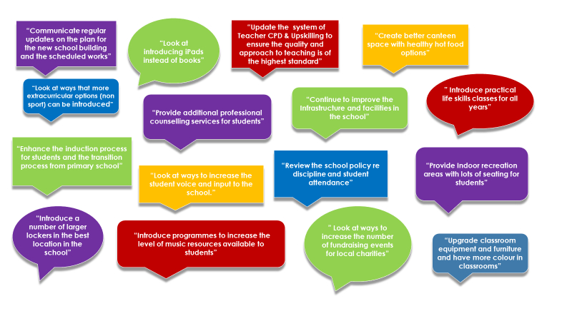

# What We Heard From Our Staff

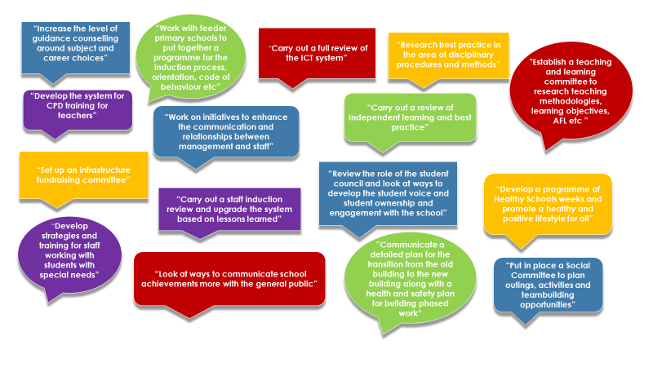

# What We Heard from Our Parents

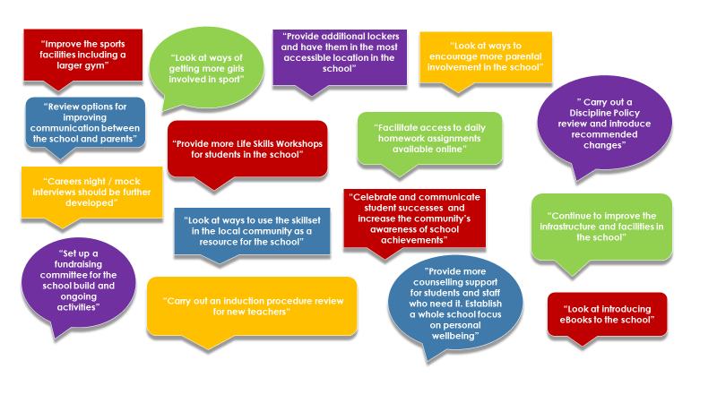

# Strategic Framework

**What we will be able to say in 2021:**

# Pillar 1. Teaching & Learning

**In 2021 we will be able to say….**

"Holy Family Community School achieves excellence in teaching and learning by supporting the continuous development of our students, staff and management."

| Year | Actions | Achievement Milestones | Notes |
| --- | --- | --- | --- |
| Year 1 | **Attendance & Punctuality**  Review attendance procedures and further develop strategies to improve student attendance and punctuality. | Review strategies identified and develop a Statement of Strategy for School Attendance by end of September, 2017. |  |
|  | **School Self Evaluation**  Carry out an evaluation of mixed ability teaching and write a report on recommended actions. | Evaluation of mixed ability teaching carried out and report presented to the Board of Management by end of February, 2018. |  |
|  | **Teaching and Learning Committee**  Establish a Teaching and Learning Committee to review the Junior Cycle curriculum and research the feasibility of the introduction of one-hour classes. | Teaching and Learning Committee in place by end of September, 2017. A report presented to the staff by end of March, 2018 and to the Board of Management by end of April, 2018. |  |

|  |  |  |  |
| --- | --- | --- | --- |
| Year | Actions | Achievement Milestones | Notes |
| Year 2 | **Attendance and Punctuality**  Review Statement of Strategy for School Attendance and set new targets for school attendance. Implement and monitor revised statement. | Report on review and new targets presented to the Board of Management by end of September, 2018. |  |
|  | **School Self Evaluation**  Implement changes/recommendations arising from the evaluation of mixed ability teaching. Implement recommendations of report on one hour classes. Identify new SSE strand for coming year. Research and produce a plan for implementation. | Recommendations re mixed ability teaching and one hour classes implemented by end of August, 2018. New SSE strand identified by end of September, 2018. School Improvement Plan presented to the Board of Management by end of June, 2019. |  |
|  | **Teaching and Learning Committee**  Implement and monitor changes to the curriculum and timetable. Review assessment practices and assessment policy. | Curriculum and timetable changes implemented by September, 2018. Revised assessment policy and progress report presented to the Board of Management by end of June, 2019. |  |

|  |  |  |  |
| --- | --- | --- | --- |
| Year | Actions | Achievement Milestones | Notes |
| Year 3 | **Attendance and Punctuality**  Review Statement of Strategy for School Attendance and set new targets for school attendance. Implement and monitor revised statement. | Report on review and new targets presented to the Board of Management by end of September, 2019. |  |
|  | **School Self Evaluation**  Implement and monitor new School Improvement Plan. Review impact of mixed-ability teaching at Junior Cycle on Leaving Certificate results. | Report to the Board of Management by end of June, 2020. |  |
|  | **Teaching and Learning Committee**  Implement and monitor changes to the curriculum, timetable and assessment practices. | Report progress to the Board of Management and the whole school community by end of June, 2020. |  |

|  |  |  |  |
| --- | --- | --- | --- |
| Year | Actions | Achievement Milestones | Notes |
| Year 4 | **Attendance and Punctuality**  Review Statement of Strategy for School Attendance and set new targets for school attendance. Implement and monitor revised statement. | Report on review and new targets presented to the Board of Management by end of September, 2020. |  |
|  | **School Self Evaluation**  Review School Improvement Plans (end of four year SSE cycle). | Report presented to Board of Management by June, 2021. |  |
|  | **Special Education Unit**  Teaching and Learning Committee to plan for the provision of the Special Unit. | Teaching and Learning Committee review completed and recommendations submitted by end of June, 2021. |  |

# Pillar 2. Infrastructure / Facilities

**In 2021 we will be able to say….**

"The ongoing construction of a new school with state-of-the-art infrastructure, resources and facilities enhances the teaching and learning environment to meet the needs of the school and the community."

| Year | Actions | Achievement Milestones | Notes |
| --- | --- | --- | --- |
| Year 1 | **New School Building**  Publish ongoing updates on the plan and timeline for the new school building, interim temporary accommodation and conversion works. Research the necessity for a further extension to the new school. | Updates have been published and distributed through the school’s communication channels. Research completed by end of May, 2018. |  |
|  | **ICT provision**  Review and research the provision of ICT in the school. Create a pilot eLearning programme. | Review completed and draft eLearning Plan developed by end of February, 2018. A pilot eLearning programme in place by end of September, 2017. |  |
|  | **Litter and Waste Management**  Review litter and waste management and re-establish a Green Schools Committee. | Review completed and programme of activities for the Green Schools Committee in place by end of December, 2017. |  |
|  | **Fundraising Committee**  Establish a Fundraising Committee and put in place reporting structures and communication channels. | Committee setup and a schedule of fundraising activities created by end of May, 2018. |  |

| Year | Actions | Achievement Milestones | Notes |
| --- | --- | --- | --- |
| Year 2 | **New School Building**  Publish updated building work plans and timelines. Review and plan staff parking and student play areas. Create a report for the Department of Education and Skills on projected student enrolment. | Updated building plans published and the review and plan completed by the time building work starts. Report submitted to Department of Education and Skills by December, 2018. |  |
|  | **ICT provision**  Review and further develop eLearning and the provision of a virtual learning environment (VLE). Research the introduction of ebooks. | Review and research work completed by end of February, 2019 and recommendations published by end of May, 2019. |  |
|  | **Litter and Waste Management**  Implement a two year action plan to achieve a Green Flag for the school. | The Green Flag programme of activities completed as per schedule and activities for next year outlined by end of May, 2019. |  |
|  | **Fundraising**  Implement a programme of fundraising activities through the Fundraising Committee. | Fundraising targets reached through the series of activities. Additional activities identified for next year by end of May, 2019. |  |

| Year | Actions | Achievement Milestones | Notes |
| --- | --- | --- | --- |
| Year 3 | **New School Building**  Publish updated building work plans and timelines. Review traffic management inside the school grounds, staff parking and student play areas. | Updated building plans published through the school’s communication channels. Traffic management review completed as Phase 1 of the building project nears completion. Liaise with the Department of Education and Skills re the provision of the extension to the new school. |  |
|  | **ICT provision**  Plan for ICT provision during the phased building of the new school. Implement recommendations re eLearning and the provision of a virtual learning environment (VLE) and ebooks. | Plan created and communicated as each phase of the building project nears completion. Recommendations implemented as infrastructure provision allows. |  |
|  | **Litter and Waste Management**  Implement year two of the action plan to achieve a Green Flag for the school. | The Green Flag programme of activities completed as per schedule outlined by end of May, 2020. Green Flag achieved by June, 2020. |  |
|  | **Fundraising**  Implement a programme of fundraising activities through the Fundraising Committee | Fundraising targets reached and additional activities identified for next year by end of May, 2020. |  |

| Year | Actions | Achievement Milestones | Notes |
| --- | --- | --- | --- |
| Year 4 | **New School Building**  Equip the new PE Hall and reinstate the football pitch. Plan the new staffroom and facilities. Research the equipment for the Autistic Unit and play areas. | PE hall equipment sourced and in place when Phase 3 of the building project is completed. Football pitch and school grounds reinstated when building work is completed. Liaise with the Department of Education and Skills re the provision of the extension to the new school. Research and plans re Staff Room and Autistic Unit completed by June 2021. |  |
|  | **ICT provision**  Plan for ICT provision during the phased building of the remainder of the new school. | Plan created and communicated as each phase of the building project nears completion. |  |
|  | **Green Flag**  Maintain the school's Green Flag through a review of ongoing activities and the identification of new initiatives. | The Green Flag programme of activities completed as per schedule and activities for next year outlined by end of May, 2021. |  |
|  | **Fundraising**  Implement a programme of fundraising activities through the Fundraising Committee. | Fundraising targets reached and additional activities identified for next year by end of May, 2021. |  |

# Pillar 3. Health, Wellbeing Lifestyle Students & Staff

**In 2021 we will be able to say….**

"Holy Family Community School successfully promotes and supports health, wellbeing and a positive lifestyle among students, staff and the community."

| Year | Actions | Achievement Milestones | Notes |
| --- | --- | --- | --- |
| Year 1 | **Catering Provision**  Review and further develop the Early Bird Enterprise and lunch facilities. | Review completed and recommendations reported by end of March, 2018. |  |
|  | **Wellbeing Committee**  Establish a Wellbeing Committee to research a Wellbeing Plan for students and staff. | Wellbeing committee established by end of December, 2017 and a needs analysis report presented by end of May, 2018. |  |
|  | **Amber Flag**  Maintain the school's Amber Flag through a review of ongoing activities and the identification of new initiatives. Raise awareness of LGBTIQ issues and supports. | Review completed and new initiatives identified by end of September, 2017. A programme to raise awareness of LGBTIQ issues developed and introduced by mid-November, 2018. The Amber Flag programme of activities completed as per schedule by June, 2018. |  |
|  | **Extra-curricular / Lunchtime / Non-Sporting Activities**  Review extra-curricular activities and develop a pilot programme for lunchtime activities and non-sporting activities. | Review of extra-curricular activities completed by end of February, 2018. Pilot lunchtime activity programme developed and introduced by end of January, 2018. Pilot programme reviewed by end of May, 2018. |  |

| Year | Actions | Achievement Milestones | Notes |
| --- | --- | --- | --- |
| Year 2 | **Catering Provision**  Implement the recommendations of the review. | Recommendations implemented. |  |
|  | **Wellbeing Plan**  Develop the Wellbeing Plan for students and staff. | Wellbeing plan developed by end of December, 2018. |  |
|  | **Amber Flag**  Maintain the school's Amber Flag through a review of ongoing activities and the identification of new initiatives. Maintain awareness of LGBTIQ issues and supports. | Review completed and new initiatives identified by end of September, 2018. A programme to maintain awareness of LGBTIQ issues developed and introduced by mid-November, 2018. The Amber Flag programme of activities completed as per schedule by June, 2019. |  |
|  | **Extra-curricular / Lunchtime / Non-Sporting Activities Review**  Implement and monitor extra-curricular activities and implement recommendations of review of lunchtime activities and non-sporting activities. | Extra-curricular and lunchtime activities implemented. |  |

| Year | Actions | Achievement Milestones | Notes |
| --- | --- | --- | --- |
| Year 3 | **Catering Provision**  Review and research lunch facilities for students and staff in the new school building. | Review completed and recommendations communicated by end of June 2020. |  |
|  | **Wellbeing Plan**  Implement the Wellbeing Plan for students and staff. | Wellbeing plan implemented by June, 2020. |  |
|  | **Amber Flag**  Maintain the school's Amber Flag through a review of ongoing activities and the identification of new initiatives. Maintain awareness of LGBTIQ issues and supports. | Review completed and new initiatives identified by end of September, 2019. A programme to maintain awareness of LGBTIQ issues developed and introduced by mid-November, 2019. The Amber Flag programme of activities completed as per schedule by June, 2020. |  |
|  | **Extra-curricular / Lunchtime / Non-Sporting Activities Review**  Review extra-curricular activities and lunchtime activities and non-sporting activities. | Review completed and updated activity programme developed and introduced by end of September, 2019. |  |

| Year | Actions | Achievement Milestones | Notes |
| --- | --- | --- | --- |
| Year 4 | **Catering Provision**  Implement the recommendations of the review of lunch facilities for students and staff. | Recommendations implemented by September, 2020. |  |
|  | **Wellbeing Plan**  Review the Wellbeing Plan for students and staff. | Wellbeing plan review completed by end of December, 2020 and recommendations implemented by end of May, 2021. |  |
|  | **Amber Flag**  Maintain the school's Amber Flag through a review of ongoing activities and the identification of new initiatives. Maintain awareness of LGBTIQ issues and supports. | Review completed and new initiatives identified by end of September, 2020. A programme to maintain awareness of LGBTIQ issues developed and introduced by mid-November, 2020. The Amber Flag programme of activities completed as per schedule by June, 2021. |  |

# Pillar 4. Communication

**In 2021 we will be able to say….**

"Holy Family Community School uses traditional and new media to effectively communicate with students, parents, staff, Board of Management, feeder primary schools and the community at large."

| Year | Actions | Achievement Milestones | Notes |
| --- | --- | --- | --- |
| Year 1 | **Administration & Communication Systems**  Install electronic noticeboards at strategic locations around the school to display information re day-to-day activities, school events, achievements etc.  Establish a calendar for whole school events, Maths Week, Science Week, Seachtain na Gaeilge. | Five electronic noticeboards installed throughout the school by end of April, 2018.  Whole school events calendar created and communicated by end of June, 2018. |  |
|  | **Induction / Communication with Primary Schools**  Review the school’s student induction process and communication with the feeder primary schools. | Review of the school’s induction process and 2 meetings with feeder primary schools re greater collaboration completed by mid June, 2018. |  |
|  | **Staff Induction**  Review the staff induction process. | Staff induction review completed by end of June, 2018. |  |

|  |  |  |  |
| --- | --- | --- | --- |
| Year | Actions | Achievement Milestones | Notes |
| Year 2 | **Administration & Communication Systems**  Review the communication channels for students, staff and parents. Set up a PR Committee to promote the school and raise awareness of school events, student and staff achievements, extra-curricular activities, students' non-school achievements, policies and procedures. | Communication systems review carried out and recommendations reported to the Board of Management by end of February, 2019. PR Committee established and a PR plan created and launched by end of June, 2019. |  |
|  | **Student Induction Procedures**  Implement, monitor and review the new student induction procedures. | Student induction procedures implemented and a review completed by end of June, 2019. |  |
|  | **Staff Induction Procedures**  Implement, monitor and review new staff induction procedures. | Staff induction procedures implemented and a review completed by June, 2019 |  |
|  | **Tutor System**  Establish a Tutor System Review Committee. Carry out a review of the school’s Tutor System | Tutor System Review Committee established by end of September, 2018. Tutor system review completed and recommendations reported by end of May, 2019. |  |

|  |  |  |  |
| --- | --- | --- | --- |
| Year | Actions | Achievement Milestones | Notes |
| Year 3 | **Administration & Communication Systems**  Review the school administration system and implement changes to communication systems. | Review of the administration system completed by June, 2020.  Communication system changes implemented and a review of progress carried out by June, 2020. |  |
|  | **Student Induction Procedures**  Implement recommendations of review of student induction procedures. | Student induction procedures implemented by end of September, 2019. |  |
|  | **Staff Induction Procedures**  Implement recommendations of review of staff induction procedures. | Staff induction procedures implemented by end of September, 2019. |  |
|  | **Tutor System**  Implement recommendations of review of Tutor system. | Recommendations implemented by end of September, 2019. |  |

|  |  |  |  |
| --- | --- | --- | --- |
| Year | Actions | Achievement Milestones | Notes |
| Year 4 | **Administration & Communication Systems**  Implement the recommendations of the reviews of the school administration and communication systems. | Administration and communication systems review completed by June, 2021. |  |
|  | **Local Community Links and Programmes**  Review links to the local community with a view to sharing of school facilities. | Consultation with the local community completed and a plan of action created by end of December, 2020. |  |

# Pillar 5. Leadership & Management

**In 2021 we will be able to say….**

"Holy Family Community School engages in strategic planning and maximises management of resources, facilities and infrastructure to ensure the smooth day-to-day running of the school. A culture of leadership development is fostered within the school communities."

| Year | Actions | Achievement Milestones | Notes |
| --- | --- | --- | --- |
| Year 1 | **New Building Project Management**  Manage the building project through all of its phases | Building project milestones completed on schedule through project management activity by the school’s management team. |  |
|  | **New Junior Cycle**  Manage the introduction of new Junior Cycle subject specifications, subject planning time and assessment arrangements | Schedule of subject planning time organised by end of August, 2017. New Junior Cycle coordinator appointed by end of September, 2017. Schedule of wholeschool CPD and Cluster Day CPD in place by end of October, 2017. Assessments arranged by end of November, 2017. |  |
|  | **Reducing Parents Expenditure**  Research cost cutting measures for parents including uniform, equipment and the introduction of a book rental scheme and consult with the whole school community. | Research completed by end of April, 2018 and a report of recommendations presented to the Board of management by the end of June, 2018. |  |
|  | **Online Payments System**  Introduce an online payments system for school trips and other fees. | Online payments system set up and phased introduction begun by end of December, 2017. |  |
|  | **Student Council / Leadership**  Review the roles of the Students' Council and mentors and research other student leadership roles. | Student Council / Leadership roles review completed and recommendations presented by end of May, 2018. |  |
|  | **Admissions Policy**  Conduct a review of the school’s Admissions Policy. | Admissions policy reviewed, amended and adopted by June, 2018. |  |
|  | **Strategic Plan Review**  Carry out a review of the Strategic Plan and adapt the plan for next year accordingly. | Review and revisions completed by end of June, 2018. |  |

| Year | Actions | Achievement Milestones | Notes |
| --- | --- | --- | --- |
| Year 2 | **New Building Project Management**  Manage the building project through all of its phases | Building project milestones completed on schedule through project management activity by the school’s management team |  |
|  | **Junior Cycle**  Continue to manage the introduction of new Junior Cycle subject specifications, subject planning time and assessment arrangements. | Subject planning time schedule completed by end of August, 2018. Schedule of CPD and assessment time organised as per State Examinations Commission deadlines. |  |
|  | **Reducing Parent’s Expenditure**  Implement recommendations re cost saving measures. | Cost saving measures implemented by June, 2019. |  |
|  | **Student Leadership Roles**  Implement recommendations from review of student leadership roles. | Recommendations from review implemented by end of September, 2018. |  |
|  | **Code of Behaviour and Discipline Review**  Review the Code of Behaviour and Discipline. | Review of the Code of Behaviour and Discipline completed and recommendations published by end of May, 2019. |  |
|  | **Strategic Plan Review**  Carry out a review of the Strategic Plan and adapt the plan for next year accordingly. | Review and revisions completed by end of June, 2019. |  |

| Year | Actions | Achievement Milestones | Notes |
| --- | --- | --- | --- |
| Year 3 | **New Building Project Management**  Manage the building project through all of its phases. | Building project milestones completed on schedule through project management activity by the school’s management team |  |
|  | **Junior Cycle**  Continue to manage the introduction of new Junior Cycle subject specifications, subject planning time and assessment arrangements. | Subject planning time schedule completed by end of August, 2019. Schedule of CPD and assessment time organised as per State Examinations Commission deadlines. |  |
|  | **Policies and Procedures Review**  Identify school policies and procedures in need of review or development. Revise or develop the identified policies. | Policies and procudures in need of review or development identified by end of September, 2019. Identified policies and procedures revised or developed by end of June, 2020. |  |
|  | **Strategic Plan Review**  Carry out a review of the Strategic Plan and adapt the plan for next year | Review and revisions completed by end of June, 2020. |  |

| Year | Actions | Achievement Milestones | Notes |
| --- | --- | --- | --- |
| Year 4 | **New Building Project Management**  Manage the building project through all of its phases | Building project milestones completed on schedule through project management activity by the school’s management team |  |
|  | **Junior Cycle**  Continue to manage the introduction of new Junior Cycle subject specifications, subject planning time and assessment arrangements. | Subject planning time schedule completed by end of August, 2020. Schedule of CPD and assessment time organised as per State Examinations Commission deadlines. |  |
|  | **Policies and Procedures Review**  Identify school policies and procedures in need of review or development. Revise or develop the identifies policies. | Policies and procudures in need of review or development identified by end of September, 2019. Identified policies and procedures revised or developed by end of June, 2020. |  |

# Implementing and Reviewing the Plan

Following approval by the Steering Group the strategic plan will be launched. Goals and targets will be allocated to the staff committees, Principal and Deputy Principals. The school’s Senior Management Team and Board of Management will be responsible for overseeing the implementation of the plan.

The Board of Management, Principal and Deputy Principals will complete a progress review at the end of each academic year. The review will include an analysis of the relevance of future targets and the inclusion of new targets and projects that are deemed appropriate by the Board of Management, Principal and Deputy Principals.



# Acknowledgements

Many people have contributed to the development of this plan. It would be impossible to thank everyone individually. However, it is appropriate to thank a number of individuals and groups.

* Steering Group
* Teachers and Special Needs Assistants
* Students’ Council and Mentors
* Student Representatives from all year groups
* Assistant Principals and Year Heads
* Caretaking and Cleaning Staff
* Secretarial Staff
* Parents’ Council
* Board of Management
* Senior Management Team members from Feeder Primary Schools
* Online survey participants
* Planning Specialists - [www.pinta.ie](http://www.pinta.ie)