Eportal Guidelines for Parents

Overview
This document has been created by Holy Family Community School to assist parents in the use of Eportal software to access their son/daughter’s administration files. The names, subjects and other items in this document are fictitious and bear no resemblance to any student in the school.

Eportal is web-based software used by staff to access school administration records in Holy Family Community School. The software is provided by an independent company and any features in the software are controlled by this company. Consequently, it is not possible to provide customised views of records other than that which is provided already.

Eportal is used by staff in the school to record and analyse live attendance, examination results, behaviour data and to access other items. Eportal can also be used to allow parents to have live access to their son / daughter’s administration records. In general, the contact details for students is taken to be those of the student’s mother. Please contact the school if parents require a second student contact to be set up. The following guidelines provide an overview of how parents can access their son / daughter’s records.

Accessing Eportal
Enter the following link on the address bar of Internet Explorer and press the enter key on the computer: http://65.52.72.65:8080/eportal/

This should load the Eportal welcome screen below:
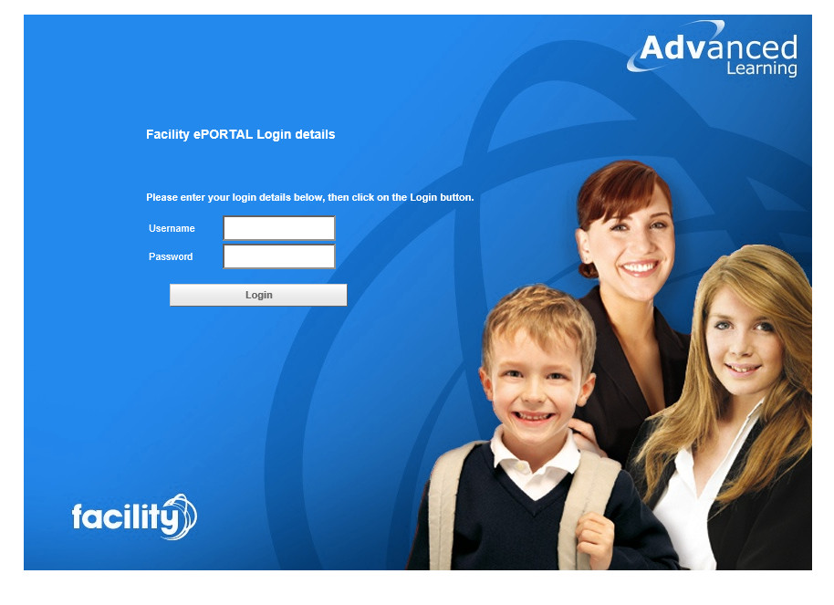
- Type your Username in the Username field and your password in the password field.
- The loading screen appears as Eportal loads the settings associated with your account. Once you have been successfully logged on, the screen will display information pertinent to your son / daughter as follows:
  - personal details;
  - timetable;
  - exam results;
  - exam reports from previous exams;
  - attendance records for the current academic year;
  - behavioural records for the current academic year;
- The initial screen which you will see will be similar to the picture overleaf.
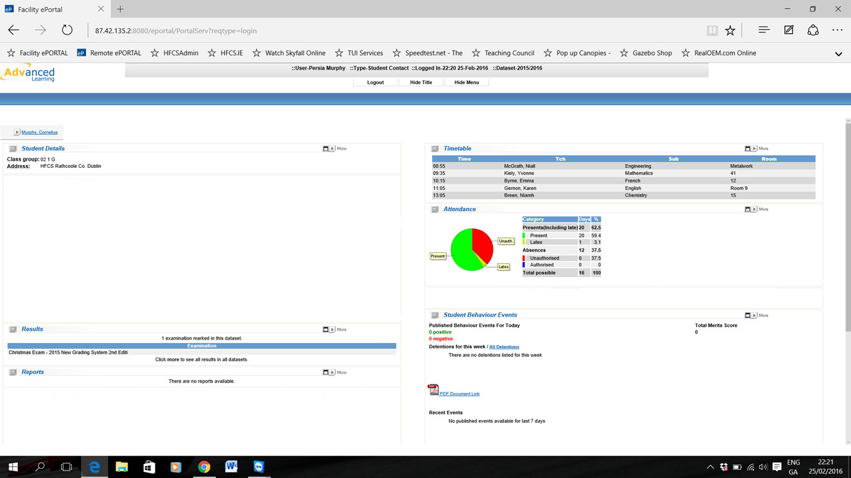

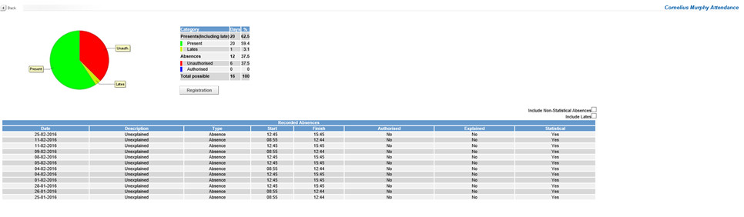
- Each of the sections on the screen has a ‘more’ icon to the right hand side. If you click on the ‘more’ icon you will see a screen which is specific to that section. For example, if you click on the ‘more’ icon in the attendance section you will see a screen similar to the following one:

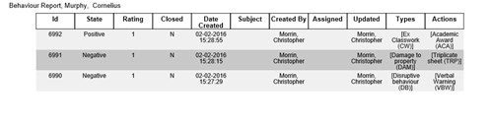
- Most of the sections have a ‘PDF Document Link’ icon. If you click on this you a webpage will be loaded which will give a view capable of being printed. For example, if you click on the ‘PDF Document Link’ icon in the Student Behaviour section a web page similar to the picture below will be loaded.

- When you have finished looking at your son / daughter’s records, it is important that you log out of the system. This can be done by clicking on the ‘Log out’ icon at the top of the screen as shown in the picture below.
- Parents are asked to take cognisance of the ‘live’ nature of the data they are accessing and also that sometimes teachers enter data retrospectively. Consequently, data may be updated a number of times before the final version is arrived at.
- Parents should note that student classes can change and that this may take some time before it is reflected in their timetable. This can sometimes result in a blank space at a timetable period during the week. However, you can rest assured that your son / daughter will have classes for every period on their timetable, irrespective of what the ‘live’ view might indicate.
- Parents should only view their own son / daughter’s records. Parents of other students will not have access to your son / daughter’s data unless you share your username and password details.
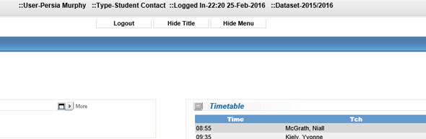
- The school welcomes any constructive feedback which will enable us to provide better access.

