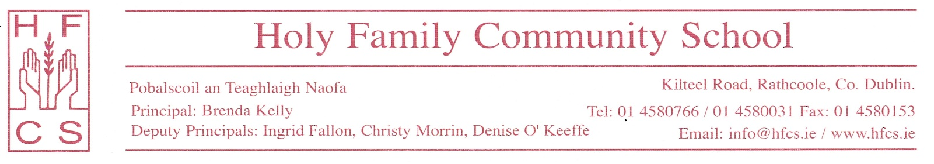

6th May, 2020

Dear 6th year students,
I understand that the need to have an online graduation has caused some upset and disappointment. I want you to know that I and all staff share your upset and disappointment as every year we look forward to graduation as a night of celebration. These are difficult and challenging times for everyone and I know that this is a particularly difficult time for all 6th year students. I would like nothing more than to have the 6th year graduation in the traditional format that has run in the school for many years. As Principal, I look forward every year to graduation night as it is a night where I get the opportunity to celebrate your achievements with you, your parents and your teachers and to formally say goodbye to all of you.
However, we are in the midst of a medical emergency and the school must follow guidelines and regulations issued by the Department of Health and the Department of Education & Skills. Current restrictions do not permit us to have a graduation ceremony in the usual format at the end of May. We do not know what lies ahead, but current forecasts suggest that having a large gathering of people for the purpose of a graduation ceremony at the start of the next academic year will not be possible. It is also likely that social distancing guidelines will still be in force. With that in mind, it was decided to have an online graduation ceremony so that all of your achievements could be recognised and celebrated, your graduation certificates could be displayed and the award winners could be announced. This joyous occasion will help to lift our spirits in these challenging times and will be a proud moment for you, your family and your school.
The graduation ceremony will be broadcast on a dedicated YouTube channel so that you and your loved ones can log in at a specific time and enjoy the evening together. This will allow all members of your family, regardless of health issues, to share in your celebration. If possible, the school will host an event in the next academic year where 6th year students would get an opportunity to say goodbye to each other and their teachers face to face.
I sincerely hope you know that every decision made by the school is made with your welfare and the welfare of your family in mind. I urge all of you to enjoy graduation night and I hope to see you all in the near future. In the meantime, stay safe and well.
Yours sincerely,
Brenda Kelly
Principal

