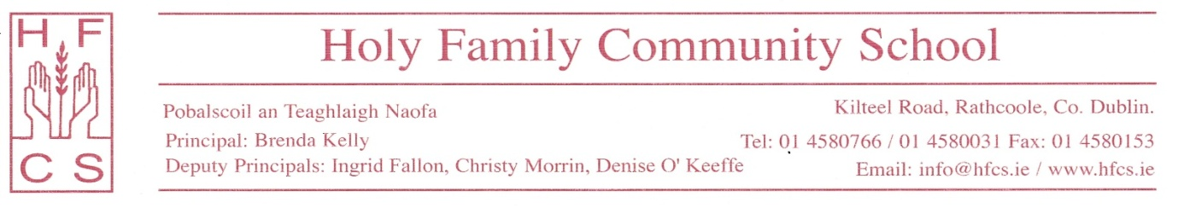
1st May, 2020

Re Revised arrangements for the completion and certification of Junior Cycle

Dear Third Year Students and Parents,
On Wednesday, 29 April, 2020, the Minister for Education and Skills, Joe McHugh, TD, announced that the Junior Cycle State Examinations will not run this year due to the Covid-19 pandemic and he outlined the revised arrangements for the completion and certification of Junior Cycle.
This year students completing their Junior Cycle will receive:
- A State Certificate of completion of Junior Cycle from the Department of Education and Skills, including the list of examination subjects studied and the level at which each subject was studied. This certificate will be issued early in the 2020/2021 school year. Please note that, just before school closure, students confirmed the level at which each of their subjects was studied and this information was submitted to the Department of Education and Skills.
- A School Report setting out the learning achievements of students in Junior Cycle, including descriptors for subjects and Classroom Based Assessments (CBAs) along with other areas of learning. This school report will be issued during June, 2020.

Using their professional knowledge of each student’s learning, teachers will base their assessment of students’ learning achievements in each examination subject on a range of evidence including:
- Third Year Mock examination result
- Second Year Summer examination result
- Second Year Christmas examination result
- CBA 2 result (if applicable to the subject)
- CBA1 result (if applicable to the subject)
- Coursework completed during Junior Cycle including assignments, projects, essays/book reviews, presentations, portfolios/briefs, practical work.

The school expects Third Year students to engage with their teachers until the end of this school year and to complete any coursework assigned to them. Please note that coursework completed online since school closure in March, 2020 and the First Year Christmas and Summer examination results may be considered in deciding a student’s descriptor if that is to the student’s advantage.

Students will be awarded one of the following descriptors for each examination subject:
- Distinction ≥90 to 100%
- Higher Merit ≥75 and <90%
- Merit ≥ 55 and <75%
- Achieved ≥ 40 and <55%
- Partially Achieved ≥20 and <40%
- Not Graded >0 and <20%

Students will be awarded one of the following descriptors for their CBAs:
- Exceptional
- Above Expectations
- In Line with Expectations
- Yet to meet Expectations

The school report will also include a statement on other students’ learning achievements including Wellbeing.
The school welcomes the decision of the Minister for Education and Skills to cancel the examinations planned for September and supports his prioritisation of the health and wellbeing of students, parents and teachers.
Finally, I wish to remind you that Third Year students are expected to engage with their teachers until the end of this school year so that course work is completed and a solid foundation for Senior Cycle is ensured. I hope you enjoy your Summer holidays and I look forward to seeing you in September.
Yours sincerely,
Brenda Kelly
Principal

