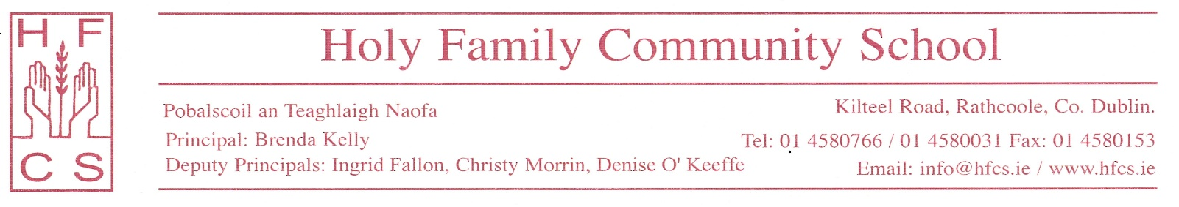
8th May, 2020

Dear Students and Parents,
We wish to thank you for your engagement in and support of online learning and teaching during these challenging times. As we approach the end of the school year, we wish to outline the reporting procedures for First, Second, TY, LCA1 and Fifth Year students.

On the Summer reports teachers will give a comment only. A mark and grade will not be recorded at this time but a level will be indicated where appropriate.

Using their professional knowledge of each student’s learning, teachers will base their comments on students learning achievements in the following areas during the period from Christmas up to the 12th of March:
- Class tests
- Coursework including assignments, projects, essays/book reviews, presentations, portfolios/briefs, practical work
- CBAs
- Engagement in classwork
- Engagement with homework

Teachers are aware of the challenges faced by students since 12th March and engagement in online learning will only be taken into account if it is to the students' advantage.

There will be Tutor comments on the reports arising out of ongoing meetings between teachers, Tutors and Year Heads. Parents will be notified by text when the reports are accessible on ePortal.

The school expects students to engage with their teachers until the end of this school year and to complete any coursework assigned to them. Work completed this year forms the foundation for next year’s work.
We wish you and your families continued good health.
Yours sincerely,
Brenda Kelly, Denise O’Keeffe, Ingrid Fallon and Christy Morrin

