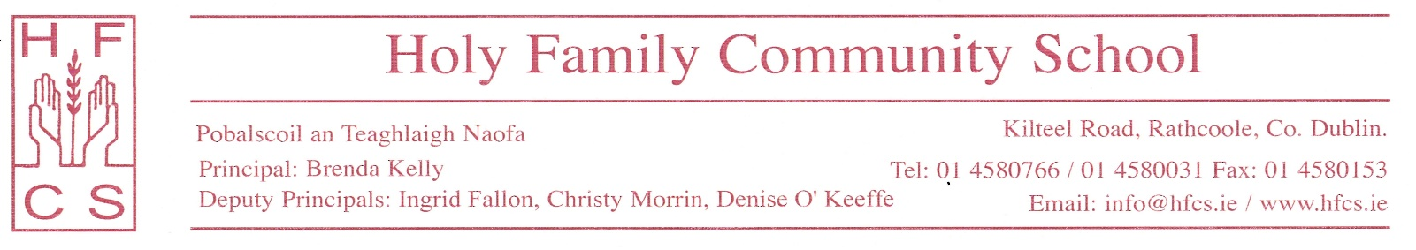

11th May 2020

Dear Parent/Guardian,

In line with government advice, Holy Family Community School would like to emphasise the importance of maintaining students’ Mental Health. Routine regarding eating, sleeping and exercising even during these strange times, is more important than ever. It gives structure to the day and is comforting amidst such uncertainty.

The government have issued a Wellbeing Information and Resources document that is very useful for young people to manage their own wellbeing. It can be found at: https://www.gov.ie/en/publication/256911-leaving-cert-2020-practical-supports/ with sleep getting a particular mention here: https://www2.hse.ie/healthy-you/shake-off-the-sleep-monster.html

Additionally, here is a link to a Jigsaw webinar for parents on Supporting Young People during Lockdown: https://jigsawonline.ie/parents-and-guardians/in-conversation-with-jen-and-vanessa/

We hope you and your family are safe and well at this time.

Regards,

Ms Perris and Ms O’Connell
Guidance Department.

