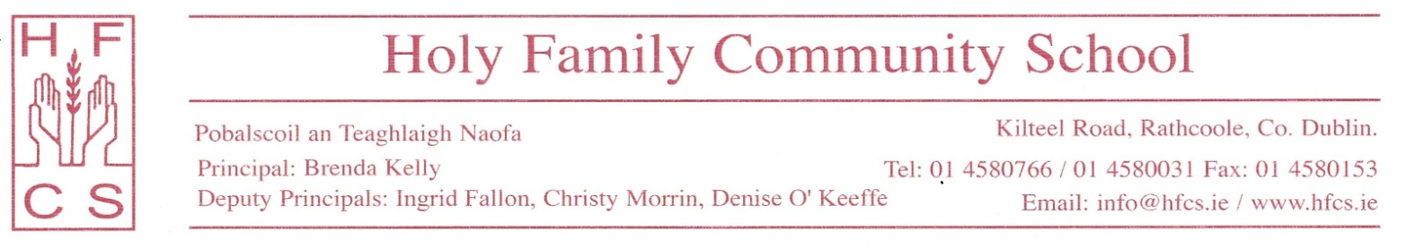

18th September 2020

Dear Parents/ Guardians,
Students have now completed two full weeks of school. Staff and students have worked very hard to adhere to HSE and DES guidelines. Thank you for your support in this difficult time. In order to keep your child safe and to continue supporting the school in maintaining safety protocols please discuss the following with your child.

- Wearing the mask correctly by covering both the mouth and nose
- Not touching the mask except by the straps
- Keeping the classroom furniture in the correct position in class to maintain a 1 metre distance
- Staying in assigned seats as per their seating plan
- Staying in their assigned base room during breaktime and lunchtime
- Maintaining social distance in the village

As the health and safety of our entire school community is important, breaches of these protocols may lead to sanctions.
Finally, please find attached below a simple guide to support you if you have COVID-19 concerns about your child. All medical issues must be directed to the HSE helpline (1850 24 1850) or your GP. The school will regularly update the website with the most current advice from the HSE and DES. Contact Tracing will issue instructions to the school re action to be taken by the school and parents in the event of positive COVID- 19 cases.

Thank you again for your support in these matters. Stay safe and well.

Yours sincerely,
Brenda Kelly

