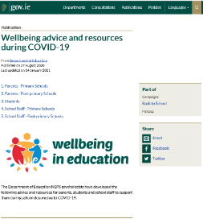
The Department of Education National Educational Psychology Service (NEPS) have many resources that you may find useful while the school is closed. These resources can be found on the Department website here and include the materails listed below.

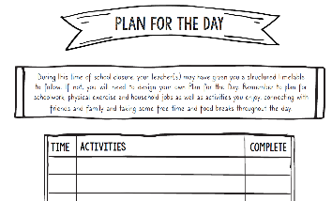
Plan for a Day
A plan for the day template is available here to help your child put a structure on the day. It suggests trying to have a schedule, creating time for fun activities, time for learning, break times and time for physical activity.

Advice for Young People
NEPS has published Advice for Young People while Schools are Closed which is available here

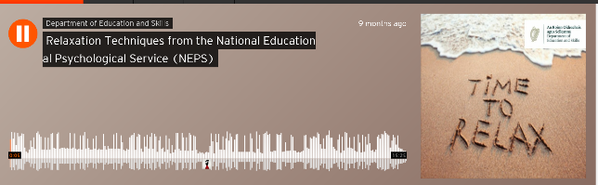
Relaxation Techniques Podcast
This link will take you to a podcast from NEPS to help parents and pupils practise relaxation techniques.

Advice for Parents
NEPS has also published A Guide for Parents on Supporting Children and Young People with Daily Routines while Schools are Closed which is available here

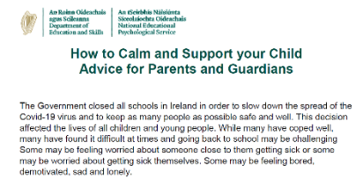
How to Calm and Support your Child – Advice for Parents and Guardians
This link here brings you to helpful tips and practical strategies to support your child if they become overwhelmed.
Managing Stress and Anxiety – A Guide for Parents and Guardians
Many young people have coped well with Covid 19 but many have found the ongoing situation upsetting and stressful. If they become more stressed and anxious
the following information here may be helpful.

