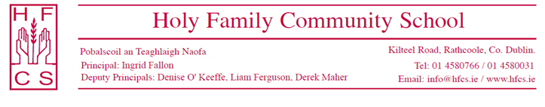

13th April 2021

Dear Parent(s)/Guardian(s),

I hope you are all keeping well in these challenging times.
We look forward to welcoming your son / daughter to Holy Family Community School in late August. We are very conscious of the difficulties all students have faced during the COVID 19 pandemic and we are putting in place the necessary plans and procedures to allow for a smooth transition for incoming first year students.
With that in mind we have compiled a number of documents, which you may find useful in terms of helping your son / daughter as they prepare for secondary school. Information on the following areas is available on the school website and via the links below;
- Wriggle Parents’ Information Pack for the School iPad Bundle
- Book Grant Application Form
- Uniform Information Pack

The Stationary List and Book List will be uploaded to the website at a later date (parents will be notified via text message).
Students have now chosen their subject option preferences and we will be in contact shortly with their subject offers. In the meantime, if you have any questions, please contact us via info@hfcs.ie.

Kind regards,
Ms Fallon
Principal

