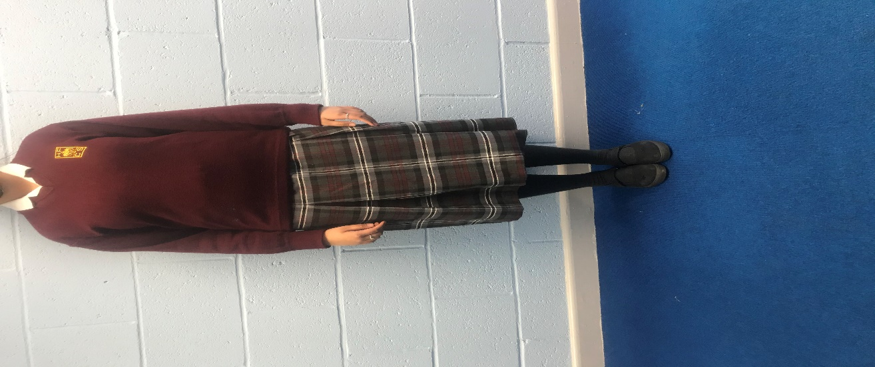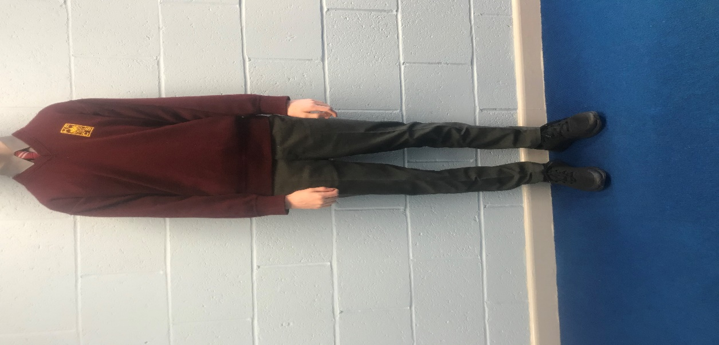

**School Uniform for Junior Students**

* **Girls –** White shirt, Wine jumper with official school crest, School skirt or grey trousers, Knee high black or grey socks / tights with skirt and black shoes.
* **Boys –** Grey shirt, wine tie, wine jumper with official school crest, grey trousers and black shoes.

**Please note that wearing the correct uniform is an important part of the school’s Code of Behaviour which is signed by all students and parents / guardians. Failure to wear the correct uniform will lead to a sanction.**

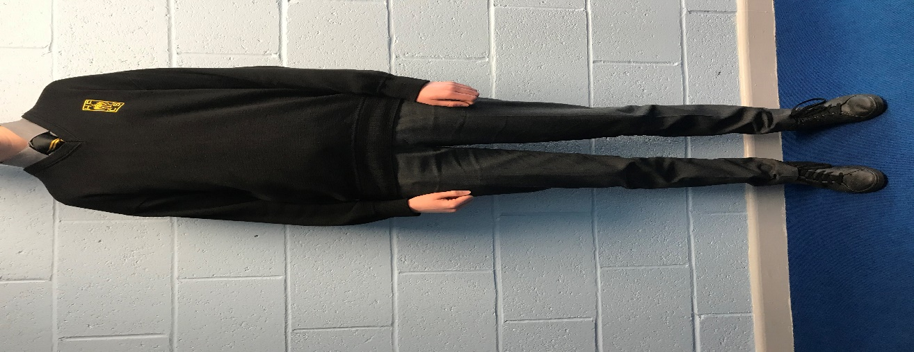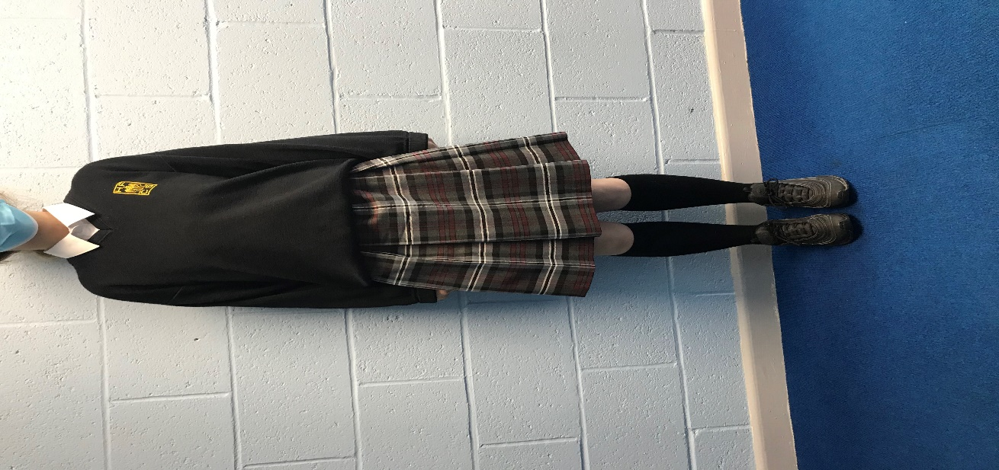

**School Uniform for Senior Students**

* **Girls –** White shirt, Black jumper with official school crest, School skirt or grey trousers, Knee high black or grey socks / tights with skirt and black shoes.
* **Boys –** Grey shirt, black tie, black jumper with official school crest, grey trousers and black shoes.

**Please note that wearing the correct uniform is an important part of the school’s Code of Behaviour which is signed by all students and parents / guardians. Failure to wear the correct uniform will lead to a sanction.**

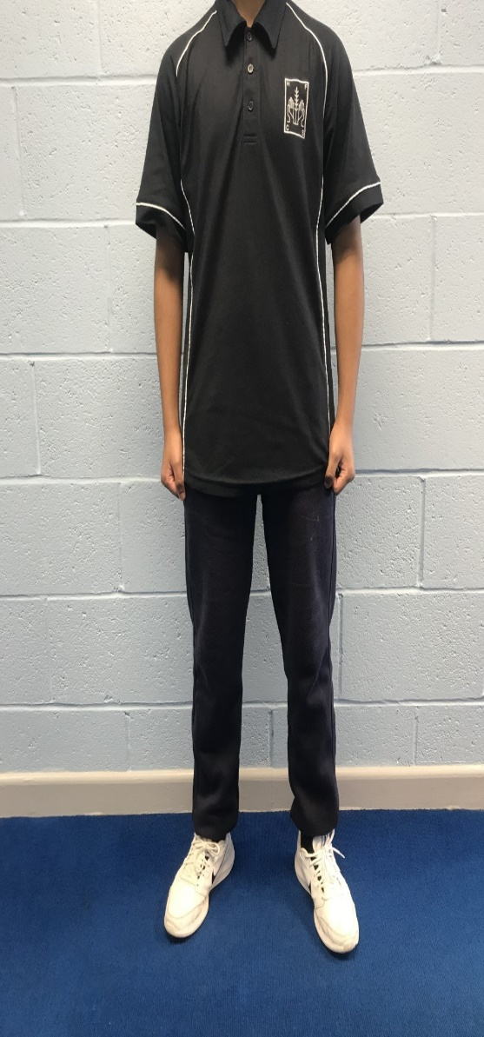 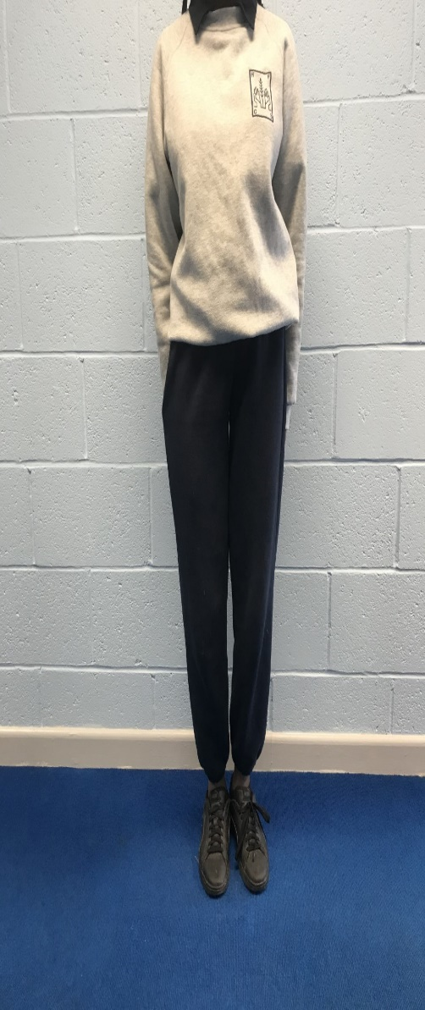

**PE Uniform**

* Students must wear the correct school PE uniform.
* Plain navy tracksuit bottoms with no logos or stripes.
* The school polo shirt and / or the school PE sweatshirt must be worn.
* Comfortable runners to be worn.
* No leggings or shorts allowed.

**The full school uniform can be purchased from The School Wear House –** [**www.schoolwearhouse.ie**](http://www.schoolwearhouse.ie)