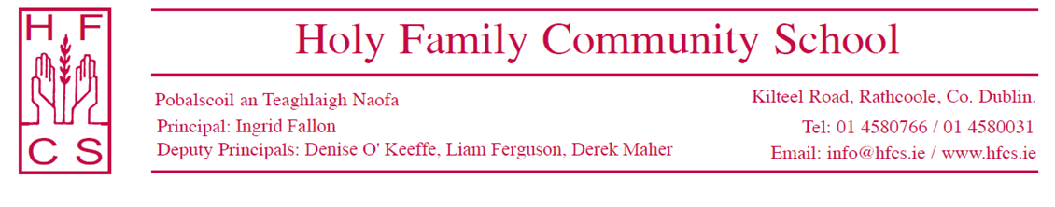
ANNUAL ADMISSION NOTICE
in respect of admissions to the 2024/2025 school year

Admission Policy and Application Form
A copy of the school’s Admission Policy and the Admission Notice for the 2024/2025 school year is available on www.hfcs.ie
The application form is now available to download on the school website www.hfcs.ie
Paper copies are available to collect from the school reception.
All applications must be fully completed and must be submitted in hard copy with the relevant documentation attached.

PART 1 - Admissions to the 2024/2025 school year

Application and Decision Dates for admission to 2024/2025 school year

The following are the dates applicable for admission to First Year

The school will commence accepting applications for admission on | 2nd October, 2023
The school shall cease accepting (on time) applications for admission on | 25th October, 2023
The date by which applicants will be notified of the decision on their application is | 14th November, 2023
The period within which applicants must confirm acceptance of an offer of admission is | 28th November 2023

Please note that failure to accept an offer within the prescribed period above may result in the offer being withdrawn. The school will consider and issue decisions on late applications in accordance with the school’s admission policy.

Number of places being made available in 2024/2025 school year

The number of places being made available in first year is | 182
The number of residential places is (boarding schools only) | N/A
The number of non-residential places is (boarding schools only) | N/A
The number of places being made available in the special class* catering for children is | N/A

PART 2 - Admissions to the 2023/2024 school year
In respect of the 2023/2024 school year, the total number of applications for admission received by the school was:
Breakdown of places allocated for the 2023/2024 school year:
Number of places available: | 182
Number of applications received on time: | 293
Number of Offers made and accepted under each criteria: | Category One: 214 applicants, all offered places  Category Two: 46 applicants, 43 offered places  Category Three:33 applicants, no places offered
Total number of offers made | 257
Number of names placed on waiting list for the school year concerned. | 48 (Including late applications)

